David Droege

SNHU CS 340

October 19, 2025

Project 2 README

**Required Functionality**  
The purpose of this project is to use Python within Jupiter Notebook through Codio to read and display data from a MongoDB database. The database contains information about different dogs, their ages, breeds, gender, and best abilities for rescue. The program I have developed enables the user to read this data with ease, while also being given pertinent information. Below are screenshots showcasing the programs' abilities.

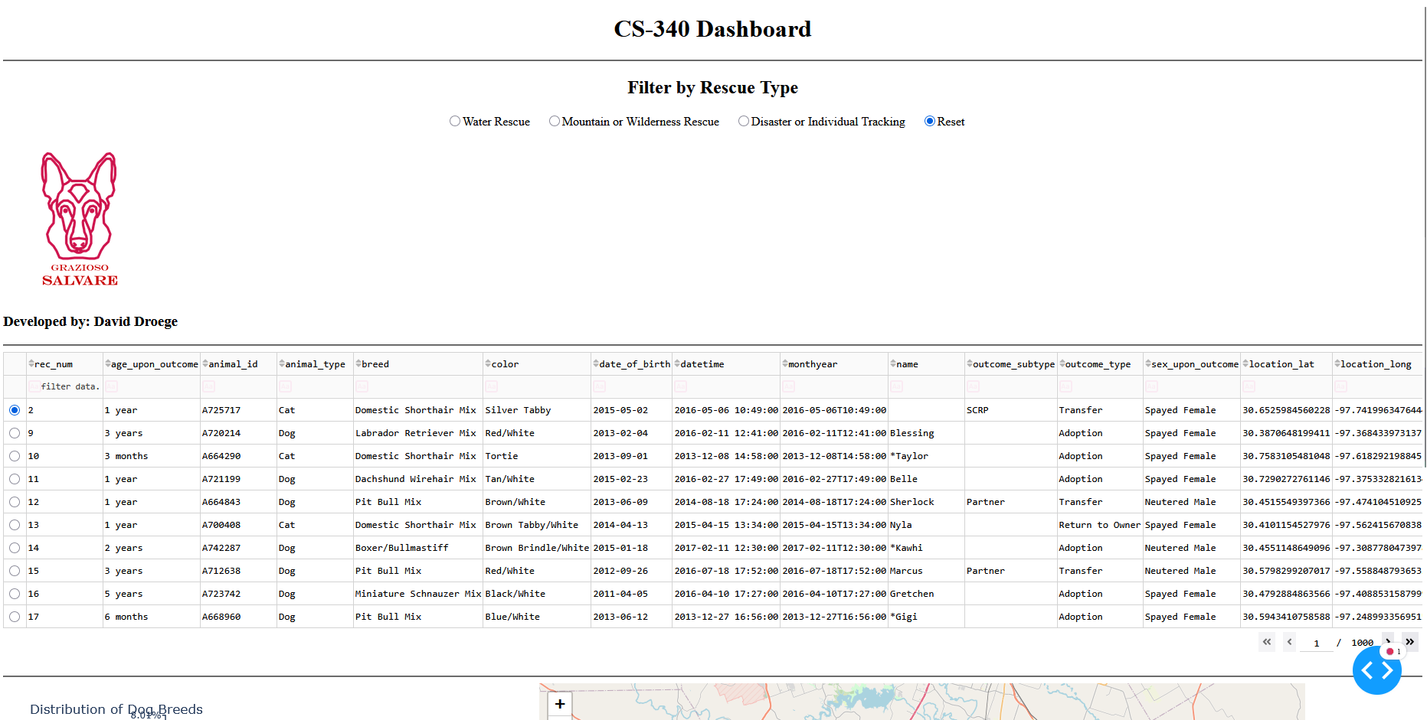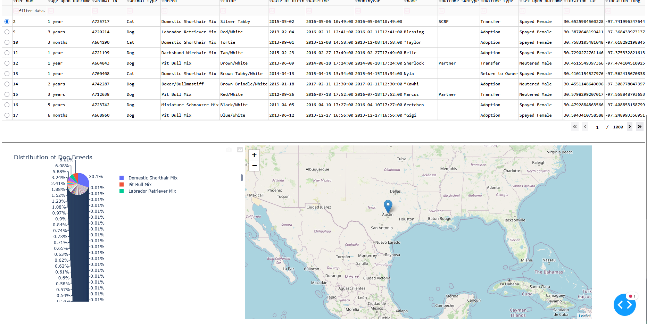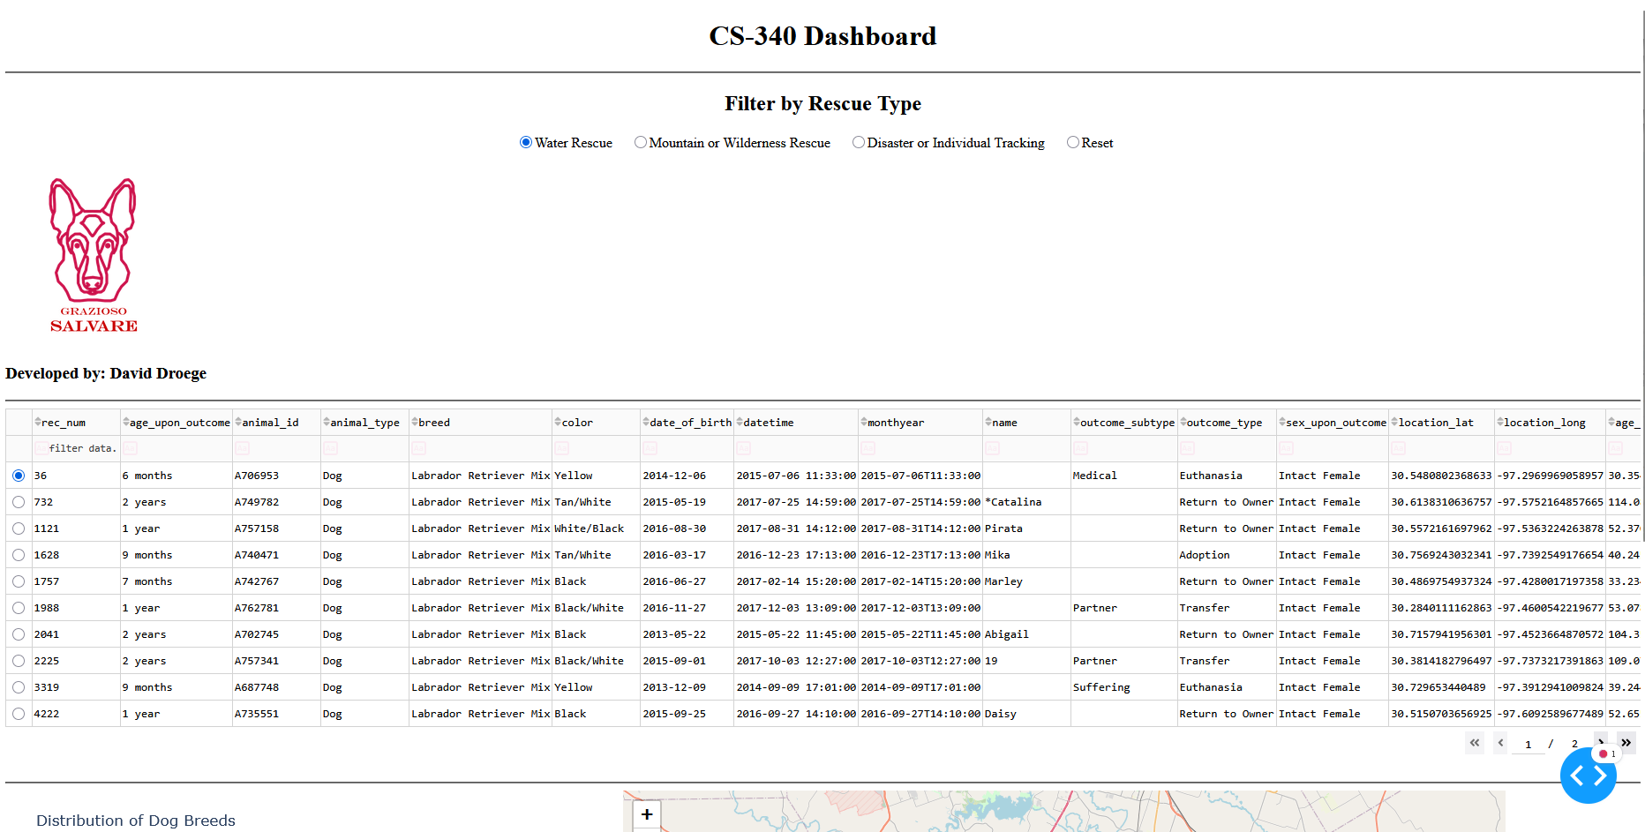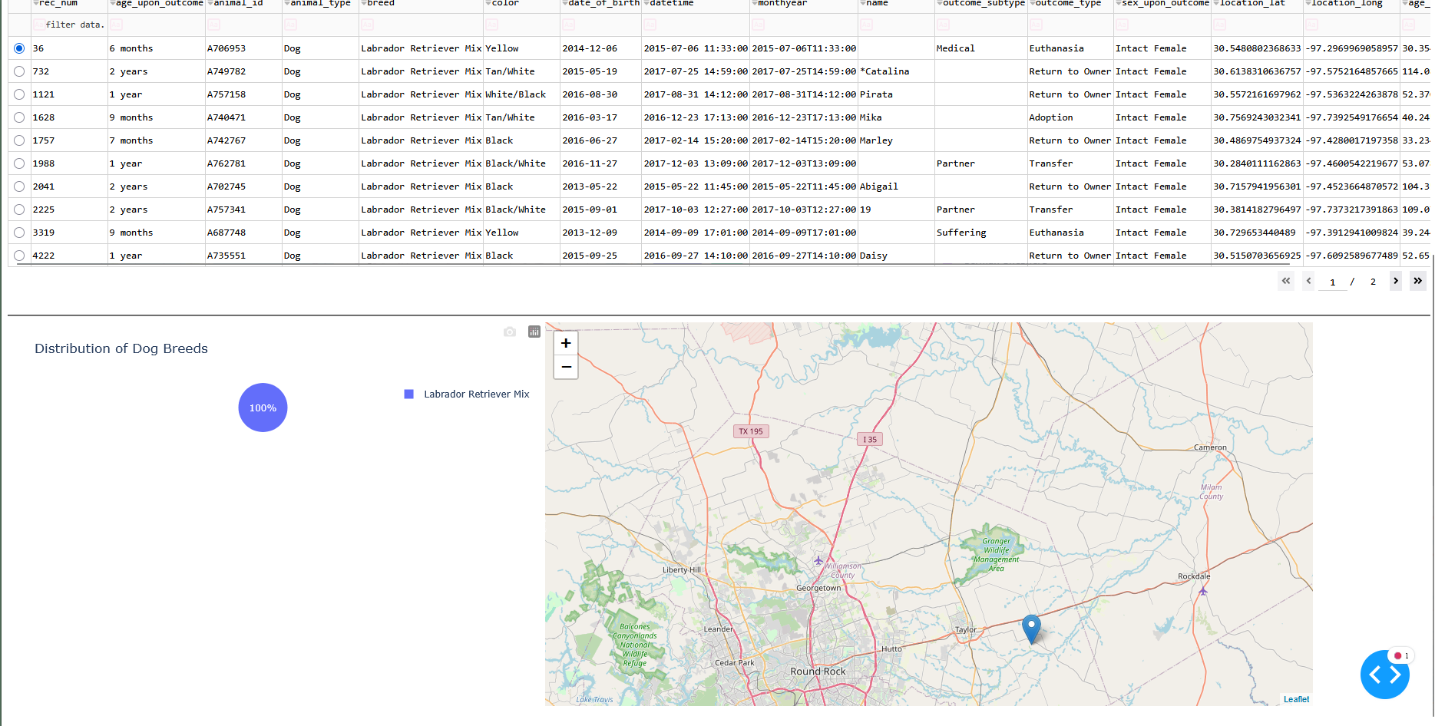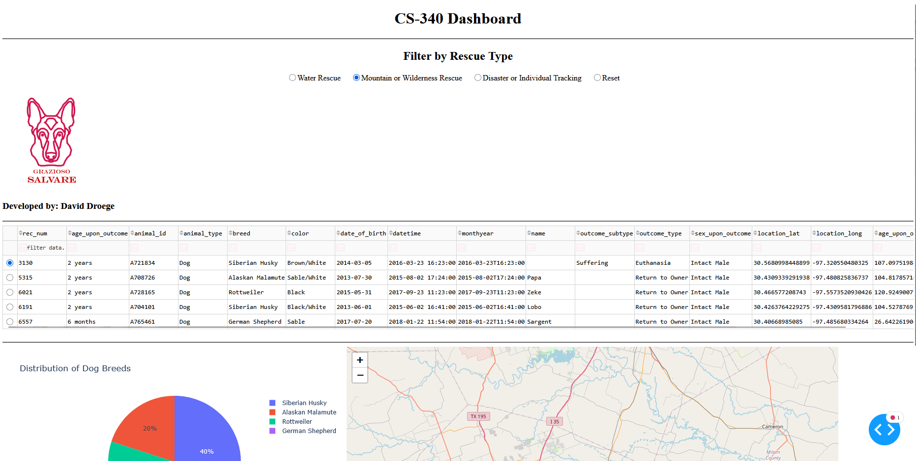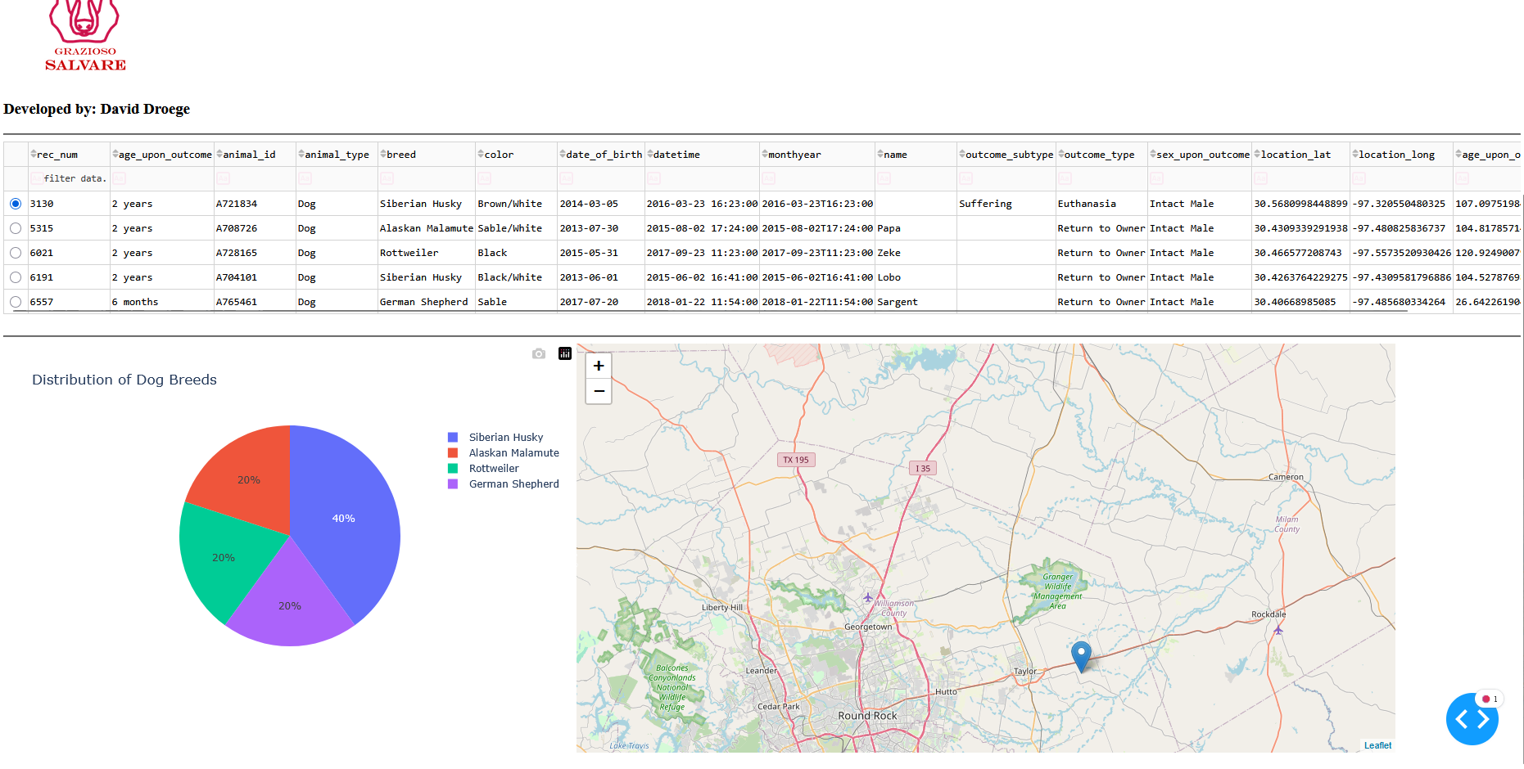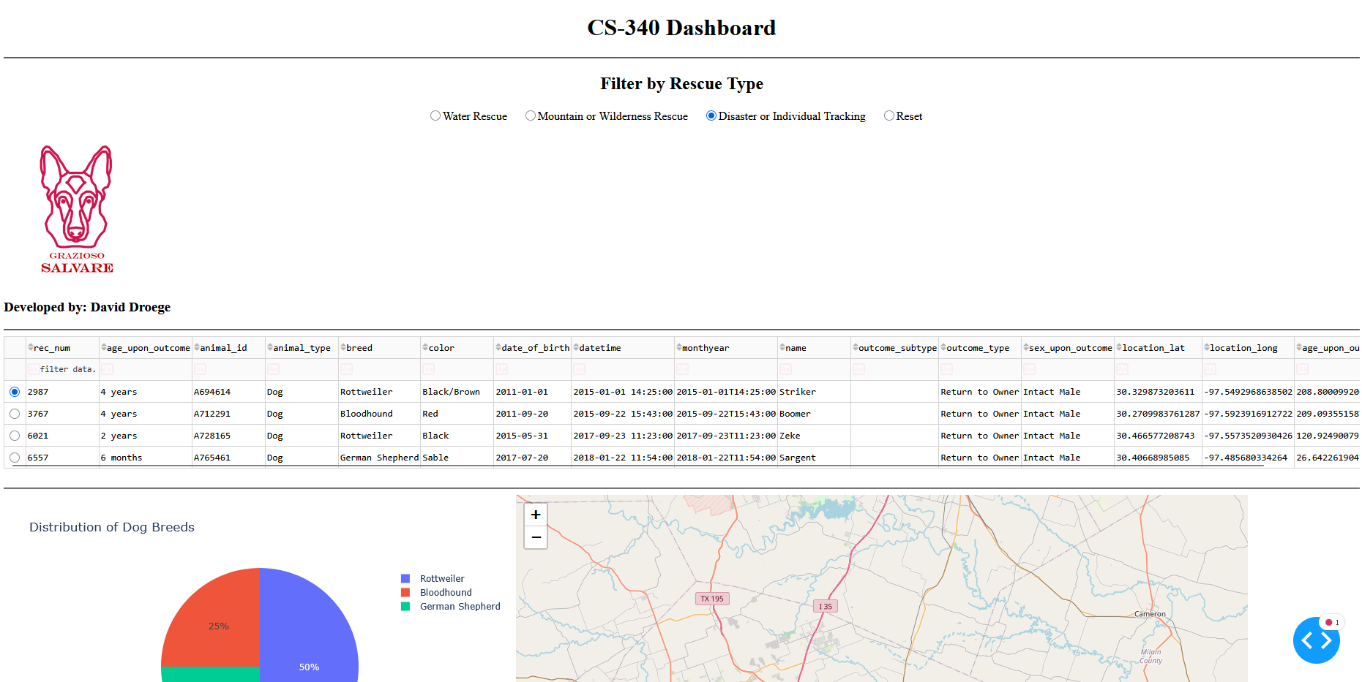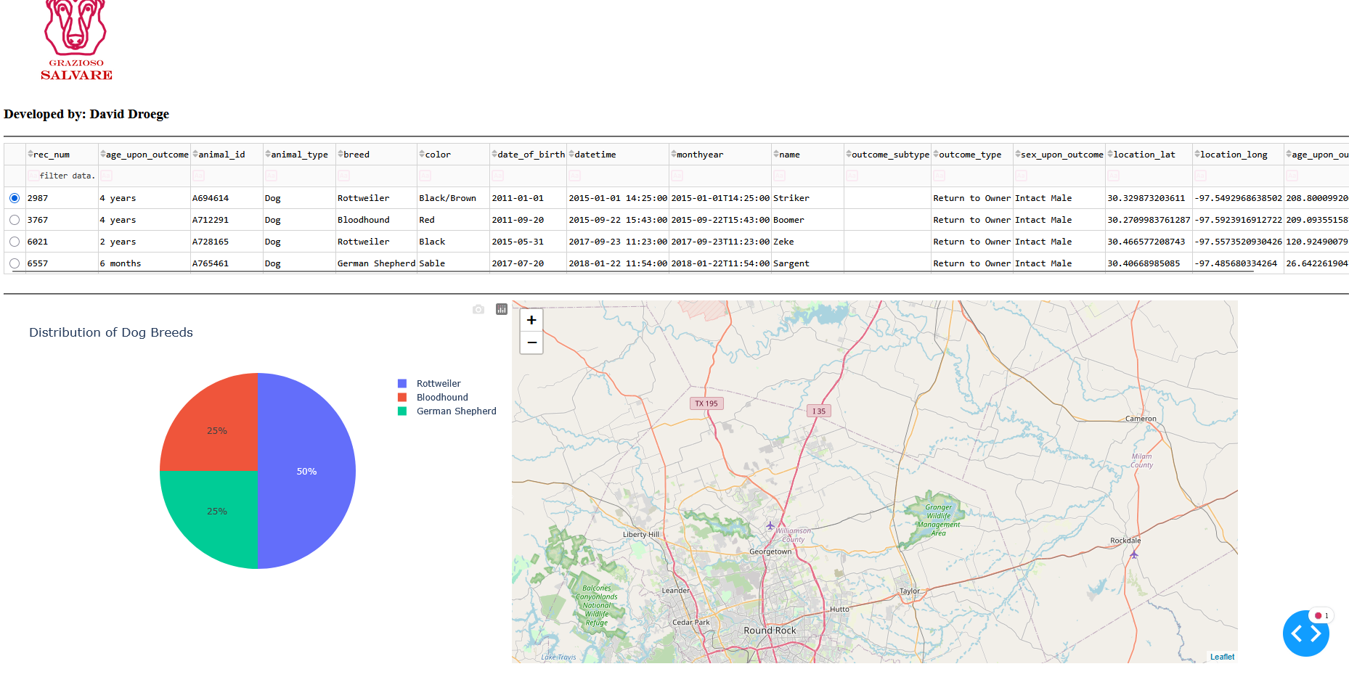

**Tools Used**

Two main tools were used, MongoDB, and Dash framework. MongoDB is crucial to this project as it is the database used to gather data. MongoDB is an example of NoSQL databases which are easier to scale and modify compared to SQL. The diverse functionality of MongoDB gives us the ability to have dynamic access to data without issue. Through MongoDB I used Python to setup CRUD capabilities with the database. Using python and CRUD practices I increased the capabilities that we have for modifying and reading the data with ease. Dash framework is the other crucial component of this project. Through Dash and MongoDB I was able to produce the program shown in the screenshots above. Dash allows the user to create links that run the program designed within the Jupyter Notebook environment. Creating programs that can cycle through the data with ease.

**Setps Taken**

The steps taken were rather simple. The first step is to learn the resources you are using. In this case, I learned about NoSQL/MongoDB and additional information on Python. After learning how to use these tools, I then read through the requirements and guidelines provided to me. After thoroughly reading through the instructions, I incrementally completed milestones and projects that were built up to this final project. The code has been provided with this assignment which allows you to recreate this project for yourself. The additional steps not shown in the code is that you must import the AAC database to your mongo and then you must create an admin account with read and write capabilities.

**Challenges**

The main challenges that I faced when working on this project were simple errors within the Python code. There were lots of practices I was unfamiliar with, so there was a learning curve for me to overcome. However, through this course and individual research online I was able to find the best practices to complete this assignment.